1. Introduction

In this project, we are going to develop an autonomous car using the TI-RSLK and the mmwave sensor (IWR1443BOOST). The autonomous car will be capable of different functions such as providing geographical information (such as range, velocity and angle) and proximity & position sensing.

## Backgound/Motivation

The TI Robotics Systems Learning Kit was created by TI as a low-cost robotics kit to provide students with a profound understanding of how electronic devices work. It was developed in conjunction with Dr Jon Valvano, professor, electrical and computer engineering at The University of Texas at Austin. There are two different RSLK kits; the basic kit which teaches the foundations of an electric system and the advanced kit which Contains all components found in basic kit, adding wireless communication to enable robot to solves its way through a maze by detecting lines and obstacles.

The mmwave sensor is an extremely valuable sensing technology for detection of objects and providing the range, velocity and angle of these objects. It is a contactless-technology which operates in the spectrum between 30GHz and 300GHz. Due to the technology’s use of small wavelengths it can provide sub-mm range accuracy and is able to penetrate certain materials such as plastic, drywall, clothing, and is impervious to environmental conditions such as rain, fog, dust and snow. The mmwave sensor has a clear advantage over other sensing technologies such as ultrasonic sensors and LIDAR. It has a long detection range, narrow and wide detection angle, good range resolution, and has good night operation performance.

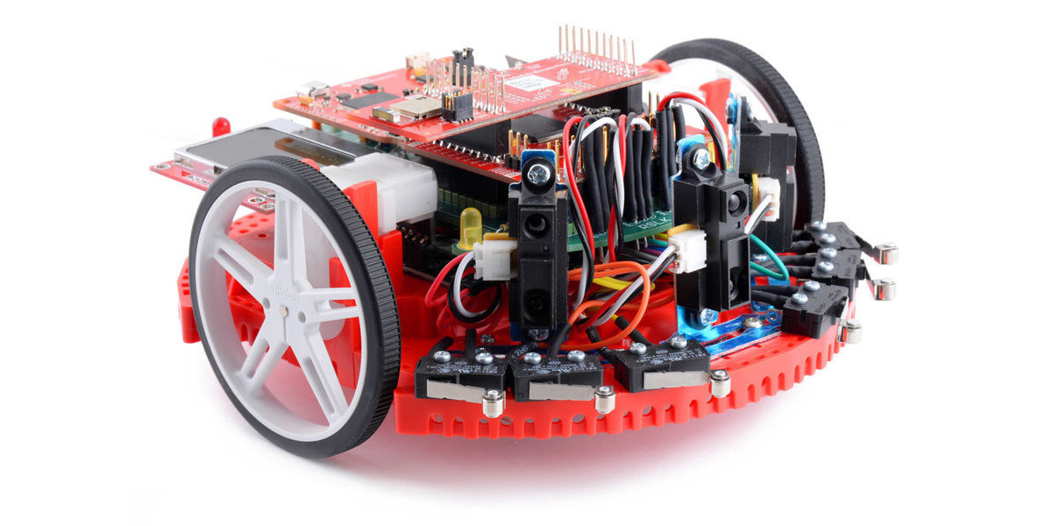

1. RSLK.

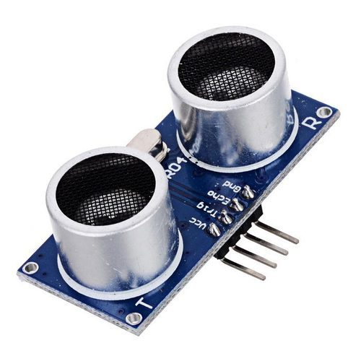

1. Ultrasonic sensor .

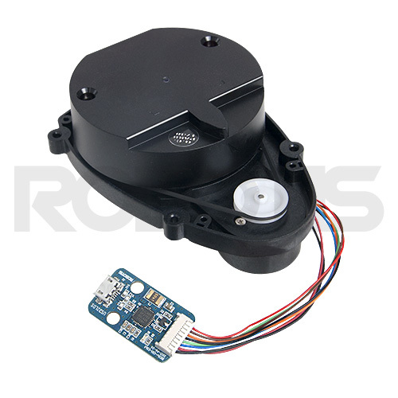

1. 360 laser distance sensor

## Objective

  The objective of the project is to design a rover that can acquire geographical acquisition such as the range, velocity, angle and 3D imaging of objects in an unknown area.

## Design Requirements

1. The device will be able to produce data using a point cloud information.
2. The autonomous car weight will be in the range 18g to 25g
3. The payload of the car will be 2 to 3 lbs
4. The device maximum velocity will be dependent on the wavelength and the observation interval. Vmax = wavelength/ 4Tc
5. The device will detect object within 20mm.

**Design Constraints**

1. The tires might not be able to move well in certain terrains such as rocky areas.
2. Battery will have to be recharged after about 4 hours of use
3. The device would only work in mild weather conditions.
4. The Tc value has to be less than 48.75µs, to have a Vmax greater than 72 kph is detectable when the wavelength is between 3.9mm and 4mm.
5. Project Description

## System Description

An autonomous car is controlled by a Ti microcontroller MSP432 power by a 12-volt battery with a voltage regulator controlling the voltage input to the microcontrollers. The battery powers the Dc motor and sends the DC signal to a PWM input on the microcontroller. A IWR 1443 Boost mmwave Rader is connected to the microcontroller to server as a senor to the car. Also, a raspberry pi is connected to the output signal of the microcontroller to control, access and save the data acquire from the sensors.

## System Diagram

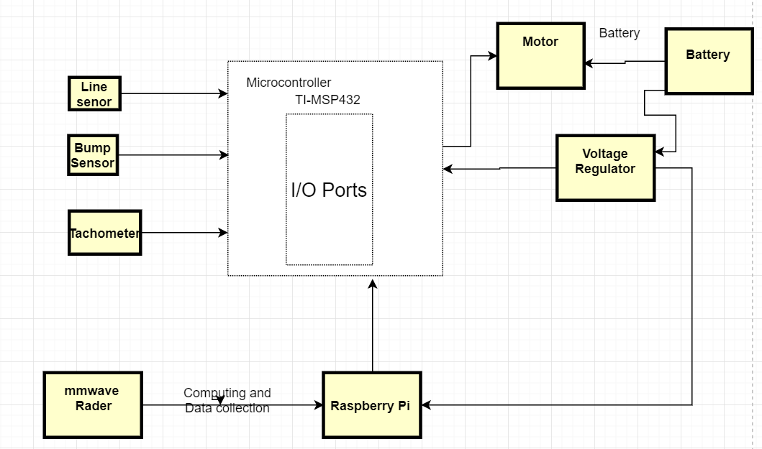

1. System Diagram.
2. Implementation Plan

## Tasks

Task 1. RLSK Assembly

1. Subtask 1. Assembly of TI RSLK Kit
2. Subtask 2. Modification of the Code for Obstacle avoidance
3. Subtask 3. Modification of the Code for Line following

Task 2. Design of the computer system

1. Subtask 1. Installing Ubuntu on Pi 3.
2. Subtask 2. Connecting the MMwave interface with the microcomputer
3. Subtask 3. Change the Pi 3 to ODROID XU4Q
4. Subtask 4. Alteration of pi code to fit the ODROID.

Task 3. Implementation and development of the MMwave sensor (IWR 1443 Boost)

1. Subtask 1. Connecting the mmwave to RSLK board
2. Subtask 2. Modify code for sensing system.

Task 4. Functions

1. Subtask 1. Acquisition of the point cloud data from the radar with the microcomputer.
2. Subtask 2. Stitching the acquired data
3. Subtask 3. Calculating the velocity independent of the wheel rotation
4. Subtask 4. Detecting and calculating the distance of an object behind the glass wall.

## Team Organization

### 3.2.1. Responsibility of Aduralere Sulaiman

Task 1, Task 3, Subtask 2, Task 4, Subtask 4, Task 6

***3.2.2.***  ***Responsibility of Favour Dada***

Task 1 Subtask 1, Task 3, Subtask 1, Task 4, Subtask 3, Task 6

### 3.2.3. Responsibility of Jesudara Omidokun

Task 1, Task 2 Subtask 2, Task 4, Subtask 1 &2, Task 5, Task 6

.…

## Timeline/Milestones/Delivery Plan

1. Project Timeline and Delivery Plan

|  |  |  |  |  |
| --- | --- | --- | --- | --- |
| **Time** | **Task** | **Comments** | **Responsible Personnel** |  |
| Week 1-4 | Task 1 | Assembly of the TI RSLK Kit  Compilation of the code | Aduralere Sulaiman  Favour Dada  Jesudara Omidokun |  |
| Week 3-8 | Task 2 | Installing of Ubuntu on Raspberry pi 3  Connecting mmWave interface with computer  Change Raspberry pi 3 to ODROID XU4Q  Alteration of Pi code to fit ODROID XU4Q | Aduralere Sulaiman  Jesudara Omidokun  Favour Dada |  |
| Week 7-12 | Task 3 | Connecting the mmWave to the RSLK  Compiling the code for mmWave senor | Aduralere Sulaiman  Favour Dada |  |
| Week 8-19 | Task 4 | Acquisition of the point cloud data from the radar with the microcomputer.  Stitching the acquired data  Calculating the velocity independent of the wheel rotation  Detecting and calculating the distance of an object behind the glass wall. | Jesudara Omidokun  Aduralere Sulaiman  Favour Dada |  |
| Week 16-19 | Task 5 | Use of Tachometer to calculate speed of rover | Favour Dada  Jesudara Omidokun |  |
| Week 19-22 | Task 6 | System finalization and delivery. Finish all documentations and ready for presentation. | Aduralere Sulaiman  Jesudara Omidokun  Favour Dada |  |
|  |  |  |  |  |

References